**MULTILEVEL FEEDBACK QUEUE SCHEDULING**

In a multilevel queue-scheduling algorithm, processes are permanently assigned to a queue on entry to the system. Processes do not move between queues. Multilevel feedback queue scheduling allows a process to move between queues. The idea is to separate processes with different CPU-burst characteristics. If a process uses too much CPU time, it will be moved to a lower-priority queue. Similarly, a process that waits too long in a lower-priority queue may be moved to a higher-priority queue. This form of aging prevents starvation.

For example, consider a multilevel feedback queue scheduler with three queues, numbered from 0 to 2.

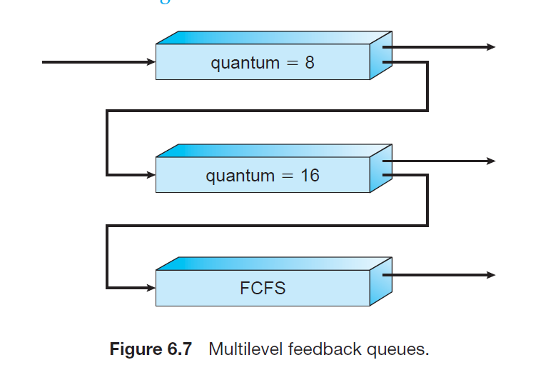

The scheduler first executes all processes in queue 0. Only when queue 0 is empty will it execute processes in queue 1. Similarly, processes in queue 2 will be executed only if queues 0 and 1 are empty. A process that arrives for queue 1 will preempt a process in queue 2. A process in queue 1 will in turn be preempted by a process arriving for queue 0.

Queues 1 and 2 follow round robin with time quantum 8 and 16 respectively and queue 3 follows FCFS. A process entering the ready queue is put in queue 0. A process in queue 0 is given a time quantum of 8 milliseconds. If it does not finish within this time, it is moved to the tail of queue 1. If queue 0 is empty, the process at the head of queue 1 is given a quantum of 16 milliseconds. If it does not complete, it is preempted and is put into queue 2. Processes in queue 2 are run on an FCFS basis but are run only when queues 0 and 1 are empty.

This scheduling algorithm gives highest priority to any process with a CPU burst of 8 milliseconds or less. Such a process will quickly get the CPU, finish its CPU burst, and go off to its next I/O burst. Processes that need more than 8 but less than 24 milliseconds are also served quickly, although with lower priority than shorter processes. Long processes automatically sink to queue 2 and are served in FCFS order with any CPU cycles left over from queues 0 and 1.

In general, a multilevel feedback queue scheduler is defined by the following parameters:

* The number of queues.
* The scheduling algorithm for each queue.
* The method used to determine when to upgrade a process to a higher-priority queue.
* The method used to determine when to demote a process to a lower-priority queue.
* The method used to determine which queue a process will enter when that process needs service.

**Advantages:**

1)In this algorithm, a process that waits too long in a lower priority queue may be moved to a higher priority queue which helps in preventing starvation.

2) This scheduling algorithm allows different processes to move between different queues.

**Disadvantages:**

1)This algorithm is too complex.

2) As processes are moving around different queues which leads to the production of more CPU overheads.